Chapter 4 sample project report

1) I did not find a significant difference in reaction time between valid & invalid
Mean invalid = 273ms
Mean valid = 279 ms
P = 0.21

2) The reaction time after the delay of 300 ms was significantly higher than after the delay of 100 ms. This agreed with my subjective experience that I wasn’t ‘as ready’ after the quicker delay.
Mean delay 100 ms = 329 ms
Mean delay 300 ms = 223 ms
P = 0

3) I did not find a clear cut relation between mean reaction time and the distance between targets. Reaction time seemed to increase with vertical distance, but decrease with horizontal or Euclidean (total) distance. I am not sure why this is. However, one confound is there are not an equal number of trials for each distance. For example, the drop of for the total distance of 4 (actually total distance >=4 and < 5) is in part because there were only 17 trials for this distance, compared to 248 for a distance of 2 (>=2 and <3).

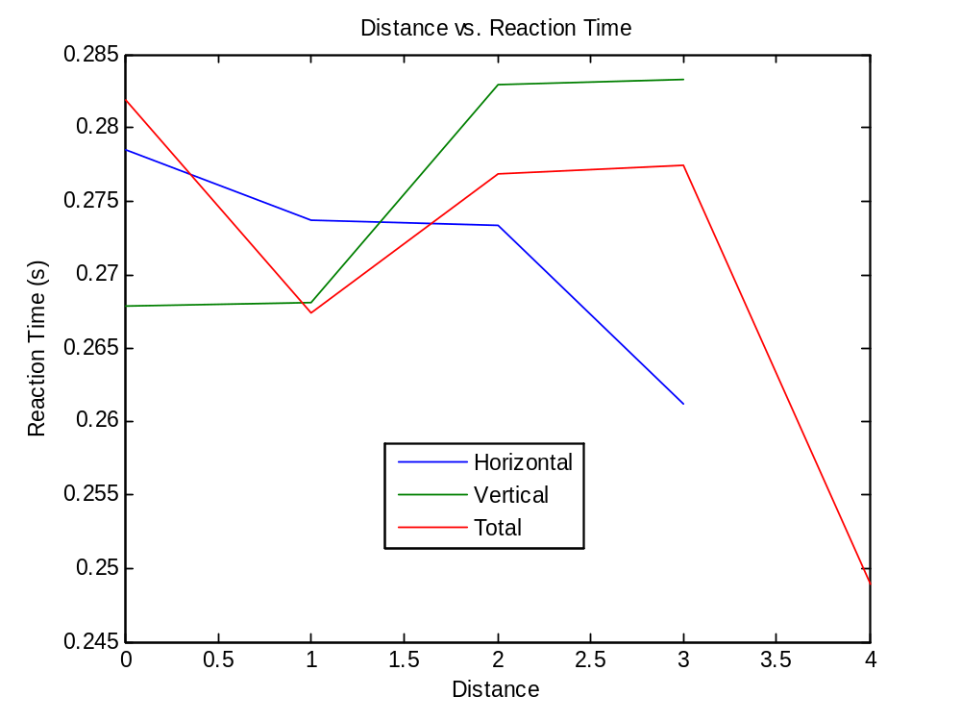

4) I can’t really compare the reaction time since my results don’t really make sense for horizontal or total distance. My only explanation is that a large change in distance might be more startling than a smaller change in distance.

5) If I just look at end points of the vertical distance graph, I get a change in reaction time of 15 ms per unit of distance, or 5 ms per unit. A unit of vertical distance was about an inch, so the speed of the attention scanner for vertical distance was 5 ms per inch.

